- Apache Kafka was originated at LinkedIn and later became an open sourced Apache project in 2011, then First-class Apache project in 2012. Kafka is written in Scala and Java.
- Apache Kafka is publish-subscribe based fault tolerant messaging system. It is fast, scalable and distributed by design.
- In Big Data, an enormous volume of data is used. Regarding data, we have two main challenges. The first challenge is how to collect large volume of data and the second challenge is to analyze the collected data. To overcome those challenges, you must need a messaging system.
- Kafka is designed for distributed high throughput systems. Kafka tends to work very well as a replacement for a more traditional message broker.
In comparison to other messaging systems, Kafka has better throughput, built-in partitioning, replication and inherent fault-tolerance, which makes it a good fit for large-scale message processing applications.
- Kafka is suitable for both offline and online message consumption. Kafka messages are persisted on the disk and replicated within the cluster to prevent data loss.
- Kafka is built on top of the ZooKeeper synchronization service. It integrates very well with Apache Storm and Spark for real-time streaming data analysis.
- Benefits of Kafka:
  - Reliability − Kafka is distributed, partitioned, replicated and fault tolerance.
  - Scalability − Kafka messaging system scales easily without down time.
  - Durability − Kafka uses Distributed commit log which means messages persists on disk as fast as possible, hence it is durable.
  - Performance − Kafka has high throughput for both publishing and subscribing messages. It maintains stable performance even many TB of messages are stored.
Kafka is very fast and guarantees zero downtime and zero data loss.
- Use Cases of Kafka:
  - Metrics − Kafka is often used for operational monitoring data. This involves aggregating statistics from distributed applications to produce centralized feeds of operational data.
  - Log Aggregation Solution − Kafka can be used across an organization to collect logs from multiple services and make them available in a standard format to multiple consumers.
  - Stream Processing − Popular frameworks such as Storm and Spark Streaming read data from a topic, processes it, and write processed data to a new topic where it becomes available for users and applications. Kafka’s strong durability is also very useful in the context of stream processing.
- Need for Kafka: Kafka is a unified platform for handling all the real-time data feeds. Kafka supports low latency message delivery and gives guarantee for fault tolerance in the presence of machine failures. It has the ability to handle a large number of diverse consumers. Kafka is very fast, performs 2 million writes/sec.
Kafka persists all data to the disk, which essentially means that all the writes go to the page cache of the OS (RAM). This makes it very efficient to transfer data from page cache to a network socket.
- Apache Kafka fundamentals:
Before moving deep into the Kafka, you must aware of the main terminologies such as topics, brokers, producers and consumers. The following diagram illustrates the main terminologies and the table describes the diagram components in detail:
Topics:
  - A stream of messages belonging to a particular category is called a topic. Data is stored in topics.
  - Topics are split into partitions. For each topic, Kafka keeps a minimum of one partition. Each such partition contains messages in an immutable ordered sequence. A partition is implemented as a set of segment files of equal sizes.
Partition: Topics may have many partitions, so it can handle an arbitrary amount of data.
Partition offset: Each partitioned message has a unique sequence id called as offset.
Replicas of Partition: Replicas are nothing but backups of a partition. Replicas are never read or write data. They are used to prevent data loss.
Brokers:
  - Brokers are simple system responsible for maintaining the published data. Each broker may have zero or more partitions per topic. Assume, if there are N partitions in a topic and N number of brokers, each broker will have one partition.
  - Assume if there are N partitions in a topic and more than N brokers (n + m), the first N broker will have one partition and the next M broker will not have any partition for that particular topic.
  - Assume if there are N partitions in a topic and less than N brokers (n-m), each broker will have one or more partition sharing among them. This scenario is not recommended due to unequal load distribution among the broker.
Thus the recommended scenario is: Number of brokers >= Number of partitions
Kafka Clusters: Kafka’s having more than one broker are called as Kafka cluster. A Kafka cluster can be expanded without downtime. These clusters are used to manage the persistence and replication of message data.
Producers: Producers are the publisher of messages to one or more Kafka topics. Producers send data to Kafka brokers. Every time a producer publishes a message to a broker, the broker simply appends the message to the last segment file. Actually, the message will be appended to a partition. Producer can also send messages to a partition of their choice.
Consumers: Consumers read data from brokers. Consumers subscribes to one or more topics and consume published messages by pulling data from the brokers.
Leader: Leader is the node responsible for all reads and writes for the given partition. Every partition has one server acting as a leader.
Follower: Node which follows leader instructions are called as follower. If the leader fails, one of the follower will automatically become the new leader. A follower acts as normal consumer, pulls messages and up-dates its own data store.
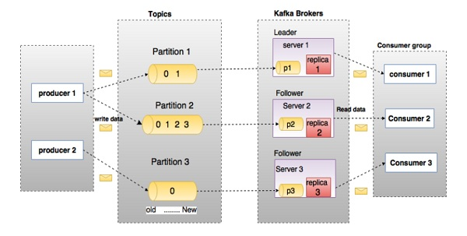
In the above diagram, a topic is configured into three partitions. Partition 1 has two offset factors 0 and 1. Partition 2 has four offset factors 0, 1, 2, and 3. Partition 3 has one offset factor 0. The id of the replica is same as the id of the server that hosts it.
Assume, if the replication factor of the topic is set to 3, then Kafka will create 3 identical replicas of each partition and place them in the cluster to make available for all its operations. To balance a load in cluster, each broker stores one or more of those partitions. Multiple producers and consumers can publish and retrieve messages at the same time.
- Apache Kafka Cluster Architecture
Take a look at the following illustration. It shows the cluster diagram of Kafka.
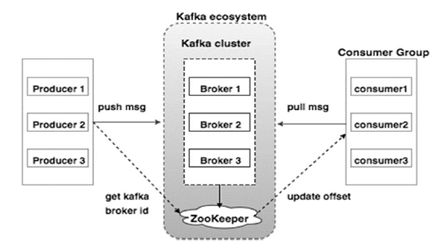

The following table describes each of the components shown in the above diagram.
Broker: Kafka cluster typically consists of multiple brokers to maintain load balance. Kafka brokers are stateless, so they use ZooKeeper for maintaining their cluster state. One Kafka broker instance can handle hundreds of thousands of reads and writes per second and each broker can handle TB of messages without performance impact. Kafka broker leader election can be done by ZooKeeper.
Zookeeper: ZooKeeper is used for managing and coordinating Kafka broker. ZooKeeper service is mainly used to notify producer and consumer about the presence of any new broker in the Kafka system or failure of the broker in the Kafka system. As per the notification received by the Zookeeper regarding presence or failure of the broker then producer and consumer takes decision and starts coordinating their task with some other broker.
Producers: Producers push data to brokers. When the new broker is started, all the producers search it and automatically sends a message to that new broker. Kafka producer doesn’t wait for acknowledgements from the broker and sends messages as fast as the broker can handle.
Consumers: Since Kafka brokers are stateless, which means that the consumer has to maintain how many messages have been consumed by using partition offset. If the consumer acknowledges a particular message offset, it implies that the consumer has consumed all prior messages. The consumer issues an asynchronous pull request to the broker to have a buffer of bytes ready to consume. The consumers can rewind or skip to any point in a partition simply by supplying an offset value. Consumer offset value is notified by ZooKeeper.
- Apache Kafka- Workflow
Kafka is simply a collection of topics split into one or more partitions. A Kafka partition is a linearly ordered sequence of messages, where each message is identified by their index (called as offset). All the data in a Kafka cluster is the disjointed union of partitions. Incoming messages are written at the end of a partition and messages are sequentially read by consumers. Durability is provided by replicating messages to different brokers.
Kafka provides both pub-sub and queue based messaging system in a fast, reliable, persisted, fault-tolerance and zero downtime manner. In both cases, producers simply send the message to a topic and consumer can choose any one type of messaging system depending on their need. Let us follow the steps in the next section to understand how the consumer can choose the messaging system of their choice.
Workflow of Pub-Sub Messaging:
  - Producers send message to a topic at regular intervals.
  - Kafka broker stores all messages in the partitions configured for that particular topic. It ensures the messages are equally shared between partitions. If the producer sends two messages and there are two partitions, Kafka will store one message in the first partition and the second message in the second partition.
  - Consumer subscribes to a specific topic.
  - Once the consumer subscribes to a topic, Kafka will provide the current offset of the topic to the consumer and also saves the offset in the Zookeeper ensemble.
  - Consumer will request the Kafka in a regular interval (like 100 Ms) for new messages.
  - Once Kafka receives the messages from producers, it forwards these messages to the consumers.
  - Consumer will receive the message and process it.
  - Once the messages are processed, consumer will send an acknowledgement to the Kafka broker.
  - Once Kafka receives an acknowledgement, it changes the offset to the new value and updates it in the Zookeeper. Since offsets are maintained in the Zookeeper, the consumer can read next message correctly even during server outrages.
  - This above flow will repeat until the consumer stops the request.
  - Consumer has the option to rewind/skip to the desired offset of a topic at any time and read all the subsequent messages.
Workflow of Queue Messaging / Consumer Group
In a queue messaging system instead of a single consumer, a group of consumers having the same Group ID will subscribe to a topic. In simple terms, consumers subscribing to a topic with same Group ID are considered as a single group and the messages are shared among them. Let us check the actual workflow of this system.
  - Producers send message to a topic in a regular interval.
  - Kafka stores all messages in the partitions configured for that particular topic similar to the earlier scenario.
  - A single consumer subscribes to a specific topic, assume Topic-01 with Group ID as Group-1.
  - Kafka interacts with the consumer in the same way as Pub-Sub Messaging until new consumer subscribes the same topic, Topic-01 with the same Group ID as Group-1.
  - Once the new consumer arrives, Kafka switches its operation to share mode and shares the data between the two consumers. This sharing will go on until the number of con-sumers reach the number of partition configured for that particular topic.
  - Once the number of consumer exceeds the number of partitions, the new consumer will not receive any further message until any one of the existing consumer unsubscribes. This scenario arises because each consumer in Kafka will be assigned a minimum of one partition and once all the partitions are assigned to the existing consumers, the new consumers will have to wait.
  - This feature is also called as Consumer Group. In the same way, Kafka will provide the best of both the systems in a very simple and efficient manner.
Role of ZooKeeper: A critical dependency of Apache Kafka is Apache Zookeeper, which is a distributed configuration and synchronization service. Zookeeper serves as the coordination interface between the Kafka brokers and consumers. The Kafka servers share information via a Zookeeper cluster. Kafka stores basic metadata in Zookeeper such as information about topics, brokers, consumer offsets (queue readers) and so on.
Since all the critical information is stored in the Zookeeper and it normally replicates this data across its ensemble, failure of Kafka broker / Zookeeper does not affect the state of the Kafka cluster. Kafka will restore the state, once the Zookeeper restarts. This gives zero downtime for Kafka. The leader election between the Kafka broker is also done by using Zookeeper in the event of leader failure.
- En

